Museums and Nature Centers — Visualization Summary
Problem Statement
There are thousands of museums, aquariums, zoos and nature centers across the United States. Using 2013 administrative and IRS records we need to understand (1) how institutions are distributed by type and geographic region, and (2) how annual revenue (reported at the parent-organisation level) varies across regions. The analysis must produce clear, audience-adapted visuals that support both high-level executive decisions and deeper analytic review.
Solution Strategy
1. De-duplicate on Legal.Name and retain only positive-revenue parents before any revenue analysis. 2. Use geom_bar / geom_col for type and region counts; switch to position = "fill" + percent_format for composition. 3. Use geom_histogram (small orgs) and geom_boxplot + coord_cartesian (large orgs) to handle the extreme right skew of revenue. 4. Compute regional means with standard errors (plotrix::std.error) and overlay geom_errorbar. 5. Apply scales (dollar, percent, wrap) and clear labs so the same plot can be re-labelled for executives, analysts or the public. 6. Add a parameterised simulation layer to test sensitivity of conclusions to revenue thresholds and sample size.
Solution
Key visual results (left: regional composition of Museum vs Non-Museum; right: mean parent revenue with SE). Historic Preservation is the most frequent type overall. Western and Mountain Plains regions show higher shares of classic museums; Midwest shows the opposite. Mean revenue is highest in New England and lowest in Mountain Plains; error bars indicate substantial uncertainty in several regions. Revenue is heavily skewed — most institutions are small (< $1 M) while a few parents exceed $1 B.
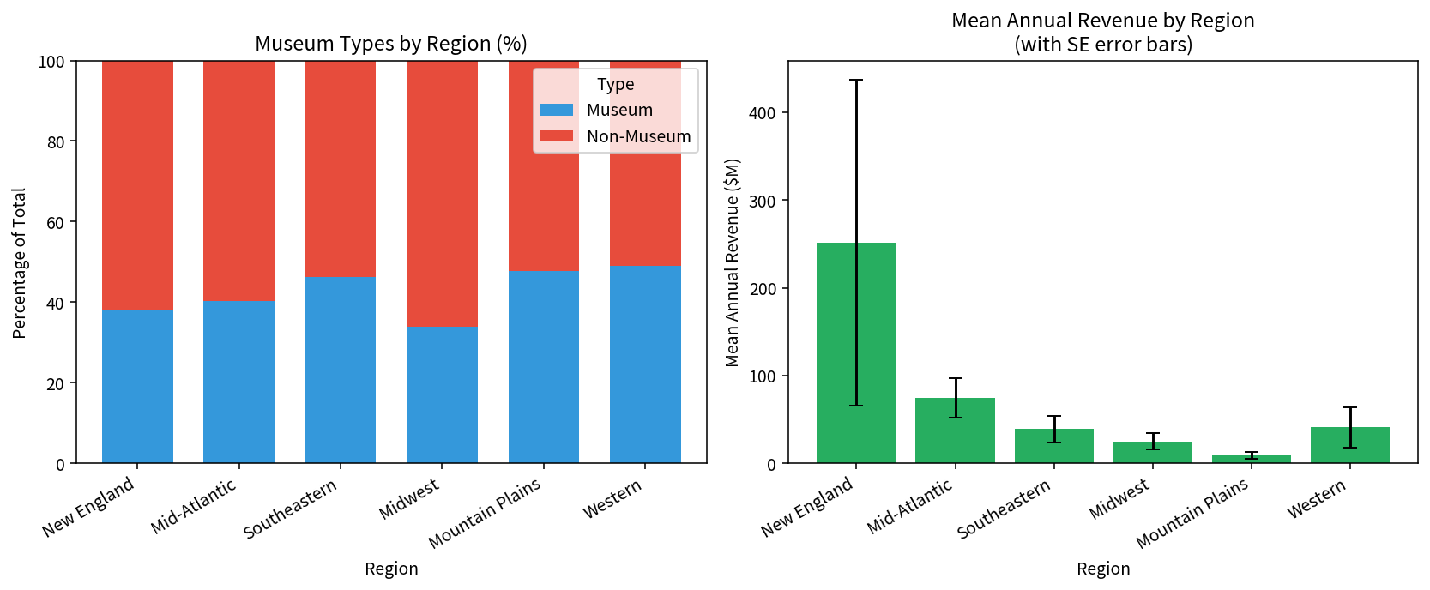
Key Takeaways
• Always de-duplicate parent organisations before analysing revenue; otherwise multi-site parents inflate totals.
• Choose geom by question: histogram for shape of the bulk, boxplot for regional comparison of the tail, filled bar for composition, mean + SE for precision of averages.
• Adapt titles, number formats and colour intensity to the audience’s data literacy and subject knowledge (see accompanying Strategy Guide and audience PDFs).
• Simulation of sample size and thresholds quickly shows which conclusions are robust and which are sensitive to filtering choices.

